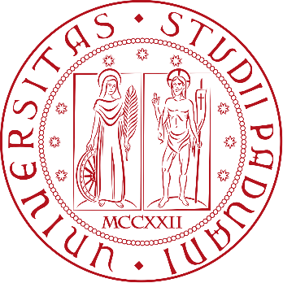

UNIVERSITÀ DEGLI STUDI DI PADOVA

SCUOLA DI SCIENZE
Dipartimento di Geoscienze
Direttore Prof. Nicola Surian

TESI DI LAUREA IN EARTH AND CLIMATE DYNAMICS

TITLE

Relatore:
Correlatore:

Laureanda/o:
Matricola:

ANNO ACCADEMICO 2025-2026

Dedica

Contents

1. Introduction 4
2. Geological setting 4
3. Methods 4
4. Results 4
5. Discussion 4
6. Conclusion and future work 4
References 4
Appendices 4
Acknowledgments 4

Abstract
The abstract is the overview of your thesis and is generally 2-3 pages long. If the thesis is in English, an Italian version of the abstract should be included.

Riassunto

1. Introduction

2. Geological setting

3. Methods

4. Results

5. Discussion

6. Conclusion and future work

References

Appendices

Acknowledgments

